Particle Effects

The following events could use a particle system

* Asteroid Collision with planet
* Asteroid Collision with other asteroids/ asteroids destroyed by defence systems
* Construction of Vanity/improvement structures on the planet

Collision Particle Effects

The grand scale of the theme of our game (Planet Management) can invoke a sense of awe in players if the effects are played correctly. The collisions between the elements of the game are colossal in a real life scale even if they are common place in the context of the game, a similar game “Pocket Universe” uses large effects on similar collisions to convey a sense of awe.

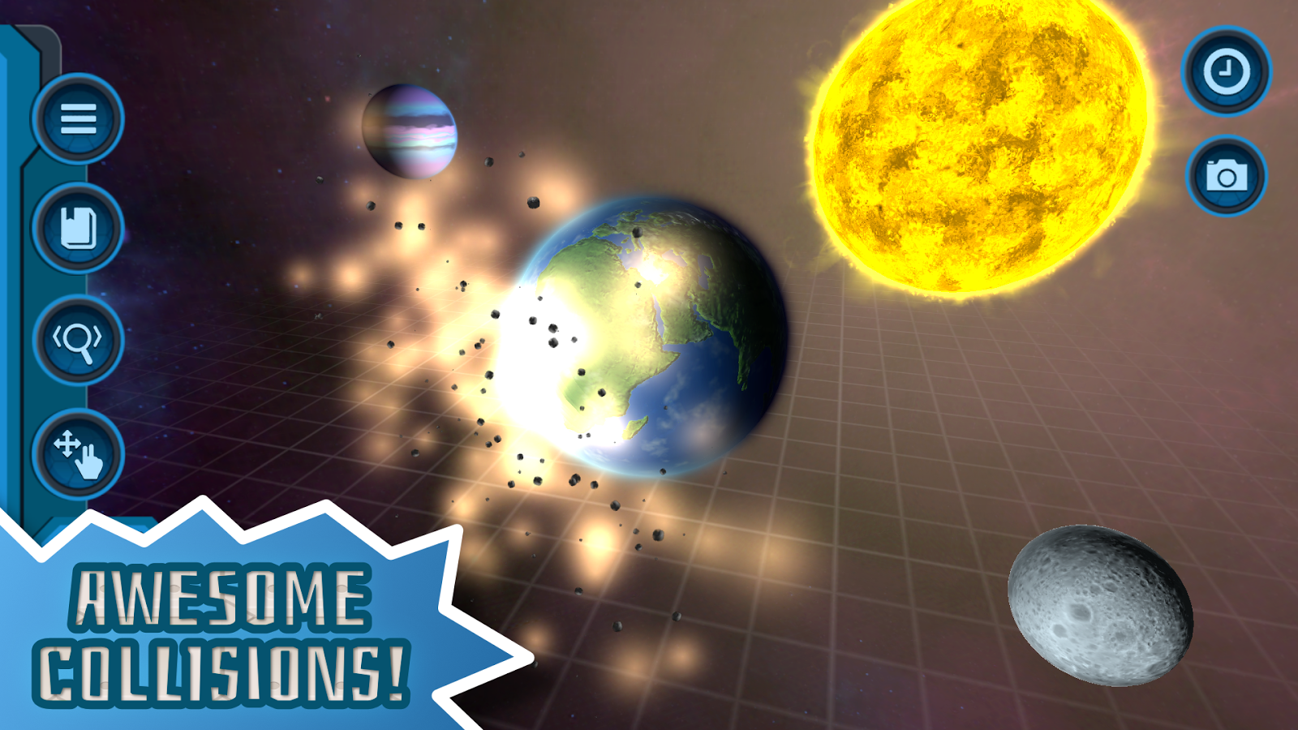

I suggest we also use large scale/scope effects to convey this same effect when asteroids collide into the planet and each other. The particles will need to be soil like in order to replicate the displacement of sediment on asteroid collision with the planets surface. Specifically when the asteroids collide into the planet the effect should obscure the player’s view of the planet for a second in order for any graphical changes to be made to the planet. This effect will rapidly fade to allow the player to fully see the game again.

Construction Effects

A possible particle effect that could enhance the game is when vanity or improvement structures are placed on the planet. In order to bring the players attention to the addition of a new structure on their planet a small glowing effect could emit from the structure for a few seconds after it has been added to the world. This effect will need to be much more subtle using a strong contrasting colour to draw attention while being much smaller than the collision effects. More like a soft glow.